<<Date>>

Dear Scout parent,

Reviewing our records from our recent FOS Presentation with your unit, we have missed your pledge/contribution. We want to make sure everyone has a chance to help support the youth of central Indiana through scouting at the Crossroads of America Council.

We can’t do it without you! Please take a few moments and fill out the below mailer and send it the Crossroads of America at 7125 Fall Creek Road, Indianapolis, IN 46256. We look forward to earning your trust through your time, talent, and treasure.

Thank you,

Unit Leader & Committee Chair

To make a donation now:
- Support online: Visit www.give2cac.org
- Text Message the phrase “give2cac” to (317) 813-7125
- Scan this QR Code with your mobile device

Or send below information to Crossroads of America of Council
7125 Fall Creek Road, Indianapolis, IN 46256

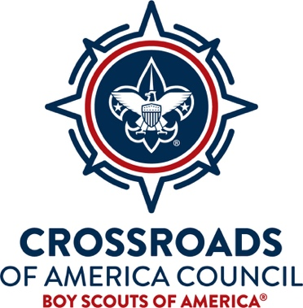
Cash
Credit Card (Visa/MC)
Check Enclosed
Payable to Crossroads of
America Council, BSA
Name:______________________________________________________
Address:_____________________________________________________
District:______________________Unit#___________________________
Email/Phone: ________________________________________________
Method of Payment
Please bill me NOW
Please bill me ONCE in (month)
Please bill me MONTHLY (Balance due December 2021)
Please bill me QUARTERLY (Balance due December 2021)
Name on Card________________________________________
Card Number __________-__________-__________-_________
Signature_____________________________________________

