Crossroads of America Council Pledge Card
2022
With your help, the Boy Scouts of America will continue to prepare young people to make ethical and moral choices over their lifetimes. Your gift will help ensure that over 26,000 youth around Central Indiana will have the opportunity to experience all that Scouting has to offer.

Donor Information

Updated information below

Contact Name: Company Name:
This is a personal donation This is a corporate donation Address: City: State: Zip: Phone: Email Address:
I am requesting a matching gift from:

Commitment Levels
Please Consider Another Donation Amount:

$1,000 Cub Scout Sponsor
$2,500 Curriculum Sponsor
$5,000 Scout Troop Sponsor
$10,000 Eagle Scout Sponsor
$20,000 District Sponsor
Other Donation: $

Method of Payment
Please bill me NOW
Please bill me ONCE in month)
Please bill me MONTHLY (Balance due December 2022)
Please bill me QUARTERLY (Balance due December 2022)
I have donated online at www.crossroadsbsa.org/donate

Cash Credit Card Check
For checks, please make payable to Crossroads of America Council, Boy Scouts of America. For stock options, we will contact you for transfer details. To donate online, please visit www.crossroadsbsa.org/donate.
BSA Structure Giving Category Table Host / Unit Donor ID #

Name on card
OFFICE USE ONLY
Card Number
Expiration Date Billing Zip

Signature Date

Contributions to Crossroads of America Council are tax deductible to the full extent of the law and benefit of the Council, staying here in Central Indiana, as Crossroads of America Council, Boy Scouts of America is a 501(c)(3) nonprofit organizations. Donations made using this pledge card are restricted to annual operations and apply to the 2022 Friends of Scouting campaign and are payable by 12/31/2022. Contributions can be sent to the Crossroads of America Council 7125 Fall Creek Road N, Indianapolis, IN 46256.

Golden-Burke Scout Center • 7125 Fall Creek Road North, Indianapolis, IN 46256 • Phone: 317-813-7125 • Fax: 317-813-7126 • www.crossroadsbsa.org
Have any comments regarding Scouting? Please feel free to share them here.

I would like more information on...
Please select as many options as you desire.

How We Are Funded

Programs
Cub Scouting™
A year-round, family-friendly program designed for children in kindergarten through fifth grade (ages 5-10). Activities are used to achieve the aims of
Scouting—citizenship training, character development and personal fitness.

Scouts BSA
A program designed for young adults ages 11-18. Scouts BSA teaches responsible citizenship, character development and self-reliance through participation
in a wide range of outdoor activities and educational programs.
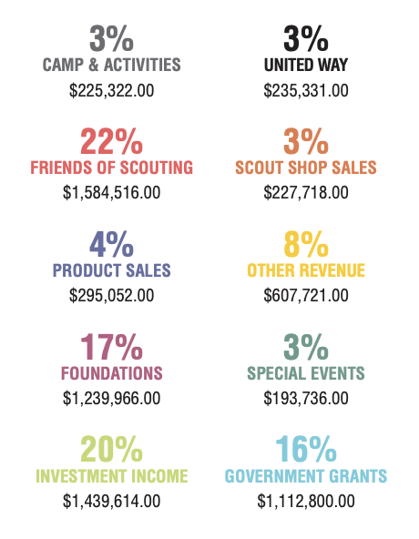

Venturing®
A high-adventure based program for young men and women between the ages of 14 and 20. Its purpose is to provide positive experiences to help youth mature and prepare them to become responsible adults.

STEM Scouts
A new program focused on fun ways for young men and women, grades 3-12, to learn more about STEM (science, technology, engineering and mathematics) using hands-on activities led by STEM professionals.

Sea Scouts
A program for young men and women ages 14-20 that promotes better citizenship and improved members’ boating skills through instruction and practice in
water safety, boating skills, outdoor, social, service experiences, and knowledge of maritime heritage.

Exploring
A career development program for young men and women between the ages of 14 and 20. Exploring units have a focus on a single career field, such as police, fire/rescue, health, law, aviation and engineering.

Reaching for Tomorrow
Reaching for Tomorrow character development program equips at-risk and special needs youth with life skills to overcome life’s challenges by providing grade-specific, character education and basic skills.

Volunteering
Start a program at my business or church Lead a year-round program
Appear as a guest speaker about a specific topic Other (please list below)

75%

How We Invest in Youth
PROGRAM SERVICES

11%
FUNDRAISING

14%
MANAGEMENT

*Numbers reflect 2020 unaudited financials

